**Assignment_2 – Josiah Moore**

Step 3.

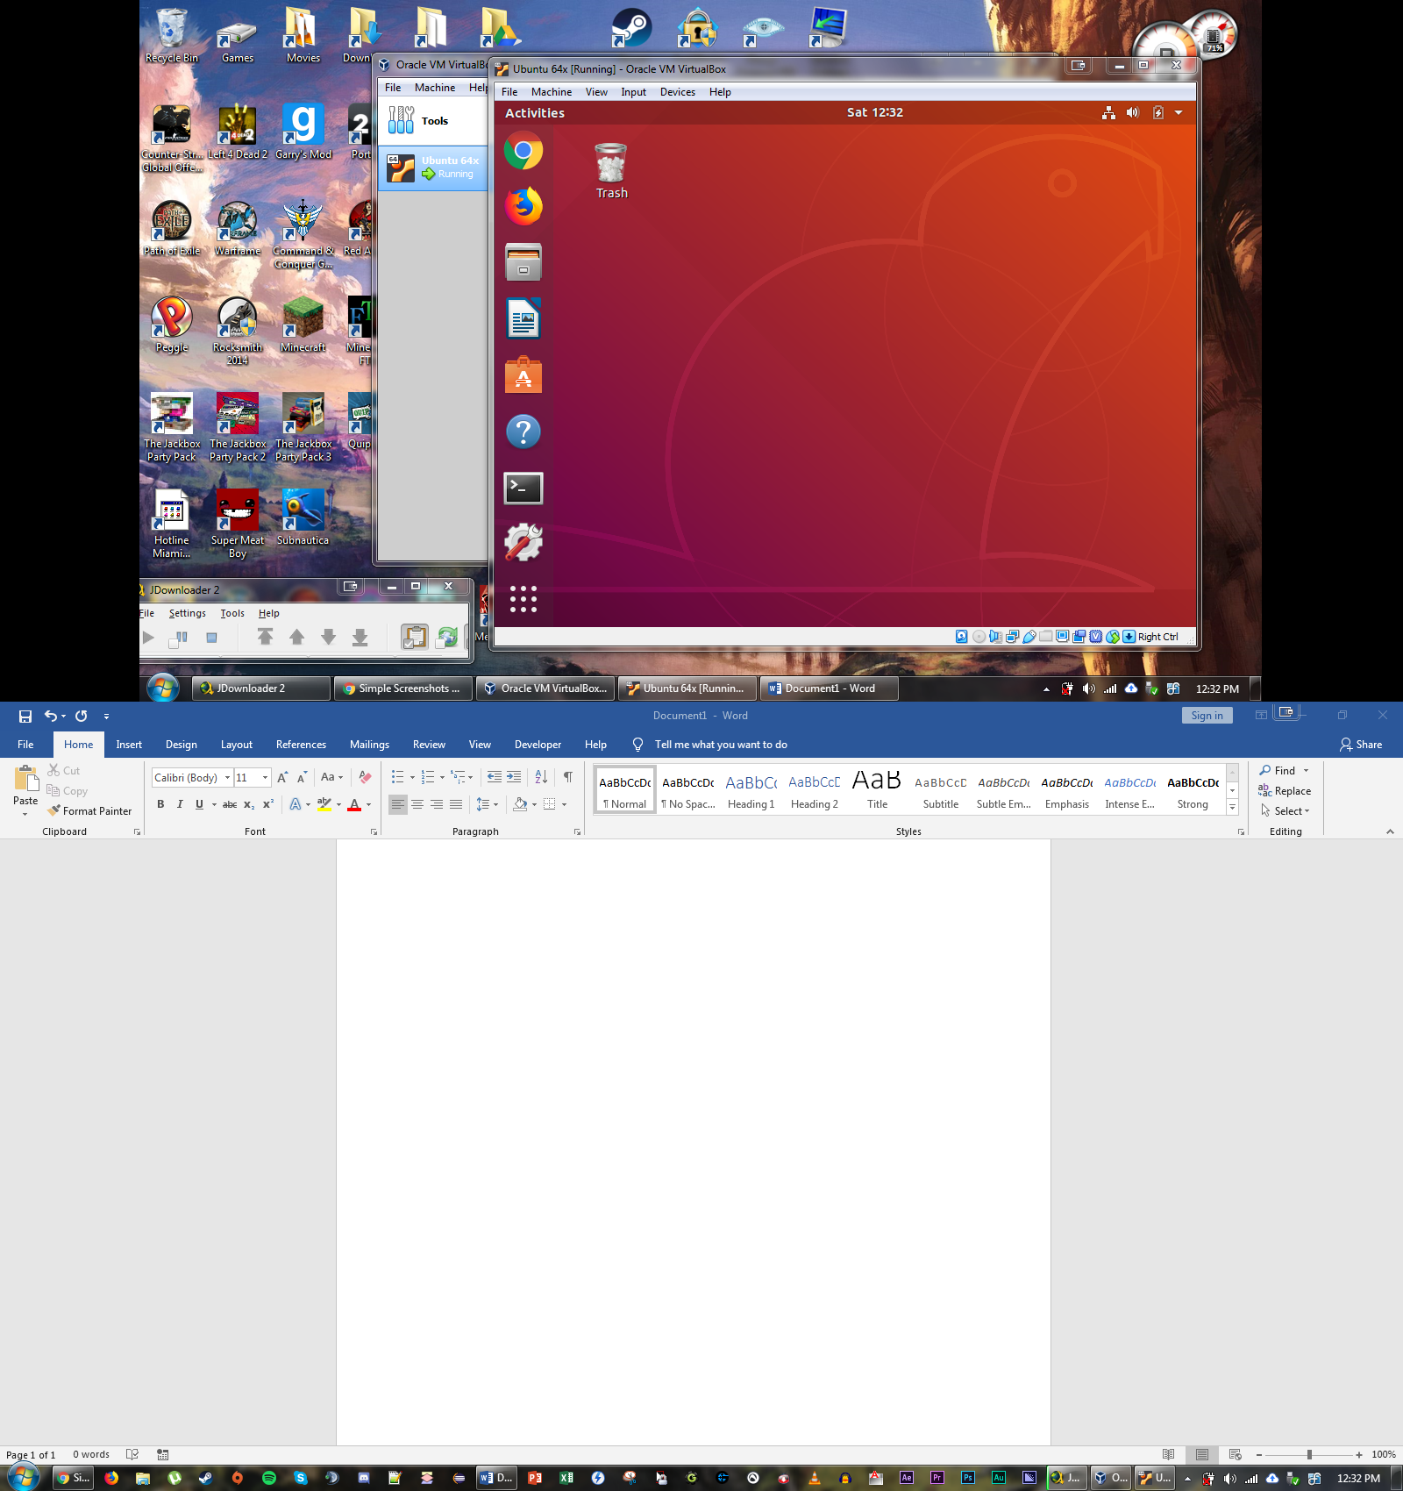

Step 7.

**Eog**: A comprehensive image viewer

**Evince**: A document viewer that supports a large number of formats

**gnome-terminal – geometry=80x30+350+150? –window-with-profile=main:** This command runs the gnome terminal, displays a 80 character and 30 line window, and puts the upper left corner at 350 pixels from the left edge and 150 pixels from the top edge of the screen. The profile is also named *main*.

Step 10.

**Libre Office** is a GUI application that supports both MS Word and Excel documents.

Step 11.

